10211CS227 – Problem Solving and Testing
Department: Computer Science and Engineering
Year / Semester: 2026-27 / Summer
Course Code / Course Name: 10211CS227 / Problem Solving and Testing

UNIT I – Functional Programming

Week 1 – Session 1
Topic: Introduction to Functional Programming Concepts

Problem: Java Lambda Expressions

Java Code
import java.util.*;
interface PerformOperation {
boolean check(int a);
}
class MyMath {
public static boolean checker(PerformOperation p, int num) {
return p.check(num);
}
PerformOperation isOdd() {
return (int n) -> n % 2 != 0;
}
PerformOperation isPrime() {
return (int n) -> {
if (n < 2)
return false;
for (int i = 2; i <= Math.sqrt(n); i++) {
if (n % i == 0)
return false;
}
return true;
};
}
PerformOperation isPalindrome() {
return (int n) -> {
int temp = n;
int rev = 0;
while (temp > 0) {
rev = rev * 10 + temp % 10;
temp /= 10;
}
return rev == n;
};
}
}
public class Solution {
public static void main(String[] args) {
Scanner sc = new Scanner(System.in);
MyMath ob = new MyMath();
int T = sc.nextInt();
while (T-- > 0) {
int ch = sc.nextInt();
int num = sc.nextInt();
PerformOperation op;
if (ch == 1) {
op = ob.isOdd();
System.out.println(MyMath.checker(op, num) ? "ODD" : "EVEN");
} else if (ch == 2) {
op = ob.isPrime();
System.out.println(MyMath.checker(op, num) ? "PRIME" : "COMPOSITE");
} else if (ch == 3) {
op = ob.isPalindrome();
System.out.println(MyMath.checker(op, num) ? "PALINDROME" : "NOT PALINDROME");
}
}
sc.close();
}
}

Output
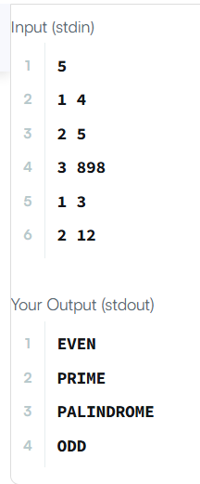

Week 1 – Session 1
Problem 2: Java Comparator
Problem Statement
Given an array of Player objects, write a comparator that sorts the players in decreasing order of score. If two or more players have the same score, sort those players alphabetically by name.
Java Code
import java.util.*;
class Player {
String name;
int score;
Player(String name, int score) {
this.name = name;
this.score = score;
}
}
class Checker implements Comparator<Player> {
@Override
public int compare(Player a, Player b) {
if (a.score != b.score) {
return b.score - a.score;
}
return a.name.compareTo(b.name);
}
}
public class Solution {
public static void main(String[] args) {
Scanner sc = new Scanner(System.in);
int n = sc.nextInt();
Player[] players = new Player[n];
for (int i = 0; i < n; i++) {
String name = sc.next();
int score = sc.nextInt();
players[i] = new Player(name, score);
}
Arrays.sort(players, new Checker());
for (Player p : players) {
System.out.println(p.name + " " + p.score);
}
sc.close();
}
}
Output
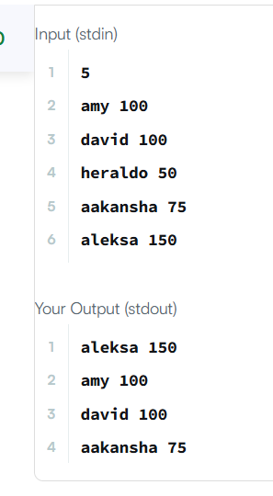

Week 1 – Session 2
Problem: Java Sort
Problem Statement
Sort the students by decreasing CGPA. If two or more students have the same CGPA, sort them by first name in alphabetical order. If both CGPA and first name are the same, sort them by ID.
Java Code
import java.util.*;
class Student {
private int id;
private String fname;
private double cgpa;
public Student(int id, String fname, double cgpa) {
this.id = id;
this.fname = fname;
this.cgpa = cgpa;
}
public int getId() {
return id;
}
public String getFname() {
return fname;
}
public double getCgpa() {
return cgpa;
}
}
public class Solution {
public static void main(String[] args) {
Scanner in = new Scanner(System.in);
int testCases = Integer.parseInt(in.nextLine());
List<Student> studentList = new ArrayList<>();
while (testCases-- > 0) {
int id = in.nextInt();
String fname = in.next();
double cgpa = in.nextDouble();
studentList.add(new Student(id, fname, cgpa));
}
studentList.sort(
Comparator.comparing(Student::getCgpa).reversed()
.thenComparing(Student::getFname)
.thenComparing(Student::getId)
);
for (Student st : studentList) {
System.out.println(st.getFname());
}
in.close();
}
}
Output
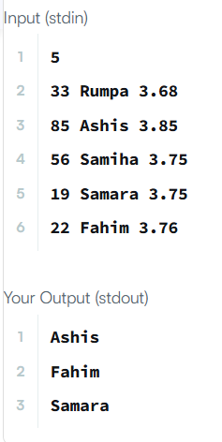

Week 1 – Session 3
Problem 1: Sorting: Comparator
Problem Statement
Given an array of Player objects, sort the players in decreasing order of score. If two or more players have the same score, sort those players alphabetically in ascending order by name.
Java Code
import java.util.*;
class Player {
String name;
int score;
Player(String name, int score) {
this.name = name;
this.score = score;
}
}
class Checker implements Comparator<Player> {
@Override
public int compare(Player a, Player b) {
// Sort by score in decreasing order
if (a.score != b.score) {
return b.score - a.score;
}
// If scores are equal, sort by name alphabetically
return a.name.compareTo(b.name);
}
}
public class Solution {
public static void main(String[] args) {
Scanner sc = new Scanner(System.in);
int n = sc.nextInt();
Player[] players = new Player[n];
for (int i = 0; i < n; i++) {
String name = sc.next();
int score = sc.nextInt();
players[i] = new Player(name, score);
}
Arrays.sort(players, new Checker());
for (Player p : players) {
System.out.println(p.name + " " + p.score);
}
sc.close();
}
}
Output
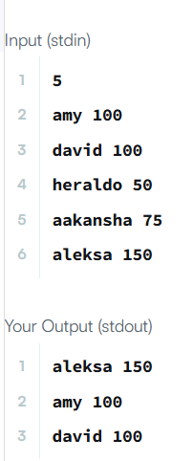

Week 1 – Session 4
Problem 1: Running Sum of 1D Array
Problem Statement
Given an array nums, return the running sum of nums, where runningSum[i] = sum(nums[0] … nums[i]).
Java Code
class Solution {
public int[] runningSum(int[] nums) {
for (int i = 1; i < nums.length; i++) {
nums[i] = nums[i] + nums[i - 1];
}
return nums;
}
}
Output
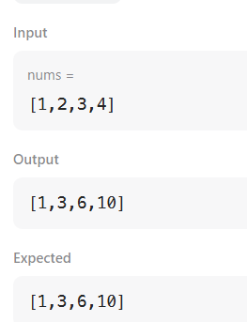

Week 1 – Session 4
Problem 2: Richest Customer Wealth
Problem Statement
Given an m x n integer grid accounts where accounts[i][j] is the amount of money the ith customer has in the jth bank, return the wealth that the richest customer has. A customer's wealth is the amount of money they have in all their bank accounts.
Java Code
class Solution {
public int maximumWealth(int[][] accounts) {
int maxWealth = 0;
for (int i = 0; i < accounts.length; i++) {
int wealth = 0;
for (int j = 0; j < accounts[i].length; j++) {
wealth += accounts[i][j];
}
maxWealth = Math.max(maxWealth, wealth);
}
return maxWealth;
}
}
Output
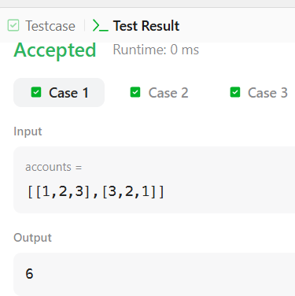

Week 1 – Session 5
Problem 1: Squares of a Sorted Array
Problem Statement
Given an integer array nums sorted in non-decreasing order, return an array of the squares of each number, also sorted in non-decreasing order.
Java Code
class Solution {
public int[] sortedSquares(int[] nums) {
int n = nums.length;
int[] result = new int[n];
int left = 0;
int right = n - 1;
for (int i = n - 1; i >= 0; i--) {
if (Math.abs(nums[left]) > Math.abs(nums[right])) {
result[i] = nums[left] * nums[left];
left++;
} else {
result[i] = nums[right] * nums[right];
right--;
}
}
return result;
}
}
Output
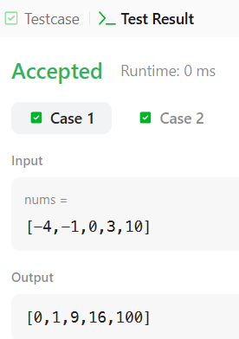

Week 1 – Session 5
Problem 2: Find Pivot Index
Problem Statement
Given an array of integers nums, calculate the pivot index. The pivot index is the index where the sum of all numbers strictly to the left is equal to the sum of all numbers strictly to the right. Return the leftmost pivot index; if none exists, return -1.
Java Code
class Solution {
public int pivotIndex(int[] nums) {
int totalSum = 0;
for (int num : nums) {
totalSum += num;
}
int leftSum = 0;
for (int i = 0; i < nums.length; i++) {
int rightSum = totalSum - leftSum - nums[i];
if (leftSum == rightSum) {
return i;
}
leftSum += nums[i];
}
return -1;
}
}
Output
